Product description
Warm edge spacer SWISSPACER Advance
- Polymer SAN spacer with 35% glass fibre content and thermally improved aluminium foil
- Equivalent thermal conductivity (in accordance with ift guideline WA-17/1): λ = 0.29 W/mK
- Available in a total of 17 RAL-like colours
RAL 9023, 9005, 9016, 5003, 8003, 8014, 1016, 6018, 6026, 7013, 1011, 1034, 6010, 1015, 1001, 7035 or 8012

Performance specification
Can be used in multi-pane insulating glass units according to DIN EN 1279
- Example structures of multi-pane insulating glass units with SWISSPACER Advance:
- Double-sheet insulating glass (6 – 16 Ar – 6): U_{g} = 1.1 W/m²K
- Triple-sheet insulating glass (6 – 12 Ar – 4 – 12 Ar – 6): U_{g} = 0.7 W/m²K

Physical values or Psi values (W/mK) for multi-pane insulating glass units with SWISSPACER Advance depending on the façade profiles
- Representative linear thermal conductivity coefficients (representative Psi values) determined according to ifa guideline WA-22/1 “Thermally improved spacers – Part 3: Determination of the representative Psi value for façade profiles”
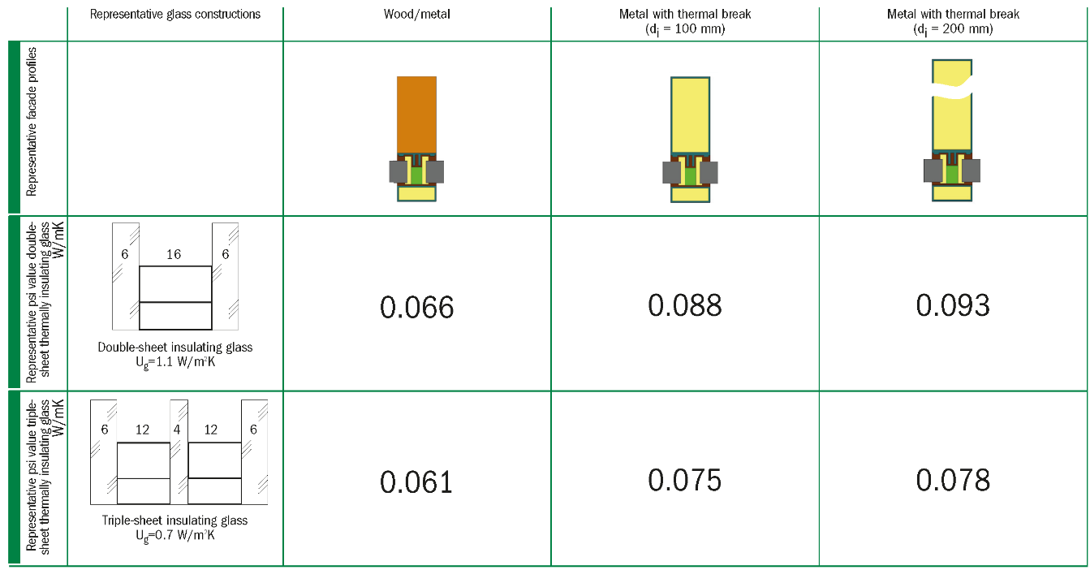
Extract from datasheet Psi façade profiles (May 2016 – No. CW24 – Revision index 3-06/2021 – valid until June 30th, 2023) © Arbeitskreis Warme Kante / Bundesverband Flachglas BF

Premium product alternative
Warm edge spacer SWISSPACER Ultimate
- Polymer SAN spacer with 35% glass fibre content and high-tech gas barrier foil
- Equivalent thermal conductivity (in accordance with ift guideline WA-17/1): λ = 0.14 W/mK
- Available in a total of 17 RAL-like colours
RAL: 9023, 9005, 9016, 5003, 8003, 8014, 1016, 6018, 6026, 7013, 1011, 1034, 6010, 1015, 1001, 7035 or 8012

Complementary product
SWISSPACER AIR for permanent pressure equalisation of insulating glass units
- The SWISSPACER AIR is a metal sleeve with an integrated special membrane. SWISSPACER AIR was developed as a permanent pressure equaliser in order to be able to transport multi-pane insulating glass units over differences in height and to minimize the distortions of the glass panes due to the climatic loads.
- Technical Approval (DIBt) No. Z-70.4-249 of 11 March 2019 for: Pressure-equalising multi-pane insulating glass units with Swisspacer Air pressure relief valve

Manufacturer
SWISSPACER Vetrotech Saint-Gobain International AG
Sonnenwiesenstrasse 15 | 8280 Kreuzlingen, Switzerland
www.swisspacer.com; info@swisspacer.com

