Product description
Warm edge spacer SWISSPACER Advance
- Polymer SAN spacer with 35% glass fibre content and thermally improved aluminium foil
- Equivalent thermal conductivity (in accordance with ift guideline WA-17/1): λ = 0.29 W/mK
- Available in a total of 17 RAL-like colours
RAL 9023, 9005, 9016, 5003, 8003, 8014, 1016, 6018, 6026, 7013, 1011, 1034, 6010, 1015, 1001, 7035 or 8012

Performance specification
Can be used in multi-pane insulating glass units in accordance with DIN EN 1279
- Example structures of multi-pane insulating glass units with SWISSPACER Advance:
- Double-sheet insulating glass (4 – 16 Ar – 4): U_{g} = 1.1 W/m²K
- Triple-sheet insulating glass (4 – 12 Ar – 4 – 12 Ar – 4): U_{g} = 0.7 W/m²K

Physical values or Psi values (W/mK) for multi-pane insulating glass units with SWISSPACER Advance depending on the window frame materials
- Representative linear thermal conductivity coefficients (representative Psi values) as defined in ifa guideline WA-08/3 “Thermally improved spacer – Part 1: Determination of the representative Psi value for window frame profiles”
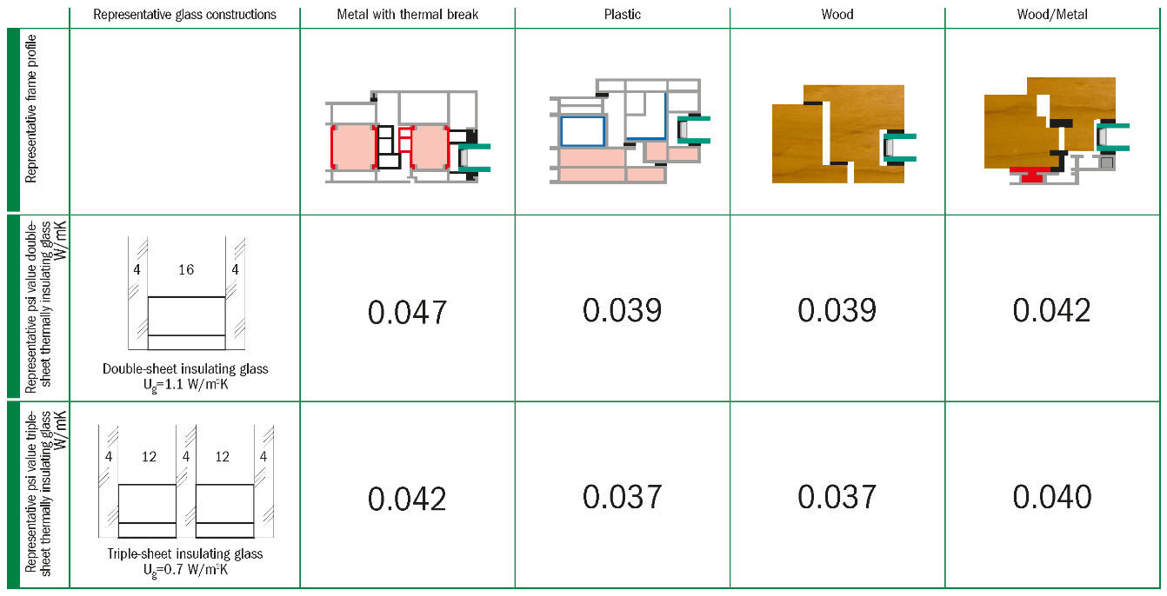
Extract from datasheet Psi values windows (August 2014 – No. W24 – Revision index 4-06/2021 – valid until June 30th, 2023)
© Arbeitskreis Warme Kante / Bundesverband Flachglas BF

Premium product alternative
Warm edge spacer SWISSPACER Ultimate
- Polymer SAN spacer with 35% glass fibre content and high-tech gas barrier foil
- Equivalent thermal conductivity (in accordance with ift guideline WA-17/1): λ = 0.14 W/mK
- Available in a total of 17 RAL-like colours
RAL: 9023, 9005, 9016, 5003, 8003, 8014, 1016, 6018, 6026, 7013, 1011, 1034, 6010, 1015, 1001, 7035 or 8012

Complementary product
SWISSPACER AIR for permanent pressure equalisation of insulating glass units
- The SWISSPACER AIR is a metal sleeve with an integrated special membrane. SWISSPACER AIR was developed as a permanent pressure equaliser in order to be able to transport multi-pane insulating glass units over differences in height and to minimize the distortions of the glass panes due to climatic loads.
- Technical Approval (DIBt) No. Z-70.4-249 of 11 March 2019 for: Pressure-equalised multi-layer insulated glazing with Swisspacer Air pressure equalisation valve

Manufacturer
SWISSPACER Vetrotech Saint-Gobain International AG
Sonnenwiesenstrasse 15 | 8280 Kreuzlingen, Switzerland
www.swisspacer.com; info@swisspacer.com

