Product description
Warm edge spacer SWISSPACER Ultimate
- Polymer SAN spacer with 35% glass fibre content and high-tech gas barrier foil
- Equivalent thermal conductivity (in accordance with ift guideline WA-17/1): λ = 0.14 W/mK
- Available in a total of 17 RAL-like colours
RAL: 9023, 9005, 9016, 5003, 8003, 8014, 1016, 6018, 6026, 7013, 1011, 1034, 6010, 1015, 1001, 7035 or 8012

Performance description
Can be used in multi-pane insulating glass units in accordance with DIN EN 1279
- Example structures of multi-pane insulating glass units with SWISSPACER Ultimate:
- Double-sheet insulating glass (6 – 16 Ar – 6): U_{g} = 1.1 W/m²K
- Triple-sheet insulating glass (6 – 12 Ar – 4 – 12 Ar – 6): U_{g} = 0.7 W/m²K

Physical values or Psi values (W/mK) for multi-pane insulating glass units with SWISSPACER Ultimate depending on the façade profiles
- Representative linear thermal conductivity coefficients (representative Psi values) as defined in ifa guideline WA-22/1 “Thermally improved spacers – Part 3: Determination of the representative Psi value for façade profiles”
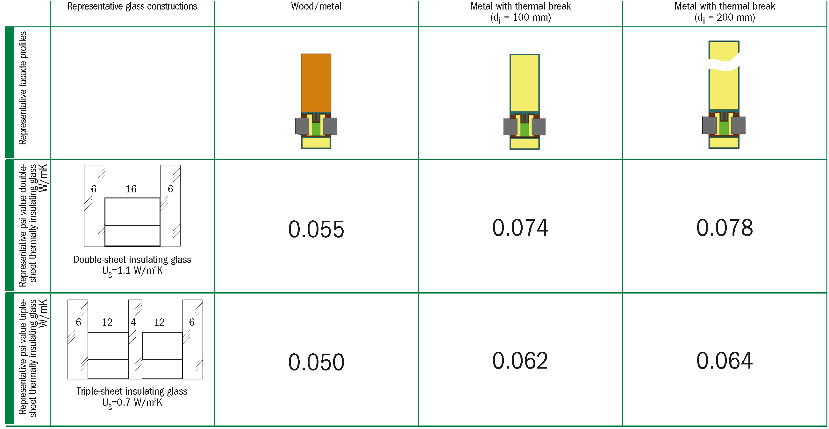
Extract from datasheet Psi values façade profiles (May 2016 – No. CW19 – Revision index 3-06/2021 – valid until June 30th, 2023)
© Arbeitskreis Warme Kante / BF Bundesverband Flachglas

Product alternative
Warm edge spacer SWISSPACER Advance
- Polymer SAN spacer with 35% glass fibre content and thermally improved aluminium foil
- Equivalent thermal conductivity (in accordance with ift guideline WA-17/1): λ = 0.29 W/mK
- Available in a total of 17 RAL-like colours
RAL 9023, 9005, 9016, 5003, 8003, 8014, 1016, 6018, 6026, 7013, 1011, 1034, 6010, 1015, 1001, 7035 or 8012

Complementary product
SWISSPACER AIR for the permanent pressure equalisation of insulating glass units
- The SWISSPACER AIR is a metal sleeve with an integrated special membrane. SWISSPACER AIR was developed as a permanent pressure equaliser in order to be able to transport multi-pane insulating glass units over differences in height and to minimize the distortions of the glass panes due to the climatic loads.
- Technical Approval (DIBt) No. Z-70.4-249 of 11 March 2019 for: Pressure-equalising multi-pane insulating glass units with Swisspacer Air pressure relief valve

Manufacturer
SWISSPACER Vetrotech Saint-Gobain International AG
Sonnenwiesenstrasse 15 | 8280 Kreuzlingen, Switzerland
www.swisspacer.com; info@swisspacer.com

